

**Superior University Lahore**

***Lab Task # 3***

**Name:** Muhammad Abdullah Kashif

**Roll No**: SU92-BSAIM-F23-070

**Instructor**: Sir Rasikh Ali

# Course: Programming for Artificial Intelligence (Lab)

# Water Jug Problem - DFS Approach

**Problem Explanation:**

The Water Jug problem is a famous problem in which we have two jugs with fixed capacities, and we need to measure a specific amount of water using these jugs. The allowed operations are:  
- Fill a jug completely.  
- Empty a jug completely.  
- Pour water from one jug to another until the first jug is empty or the second jug is full.

The goal is to determine if it is possible to measure the target amount using the given jugs.

**Code Explanation:**

The given function `waterJugDFS(cap1, cap2, goal)` solves the Water Jug problem using Depth-First Search (DFS). It explores different states by simulating all possible moves.

**Step-by-Step Working:**

**1. Initializing the Stack**

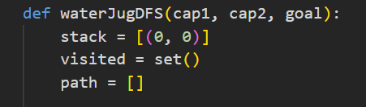  
  
The algorithm starts with both jugs empty `(0, 0)`, and we use a stack for DFS traversal.

**2. DFS Loop**

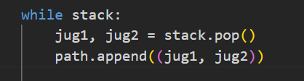  
  
 We process the last state added to the stack (DFS traversal).

**3. Checking for Solution**

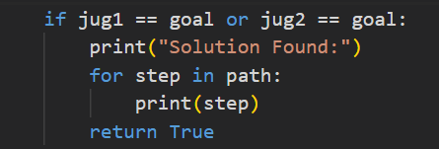  
  
If we reach the target amount in either jug, we print the solution path.

**4. Generating Possible Moves**

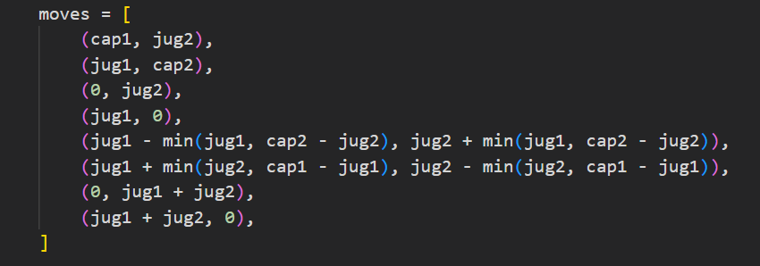

**5. Iterating through moves & User Input and Execution**

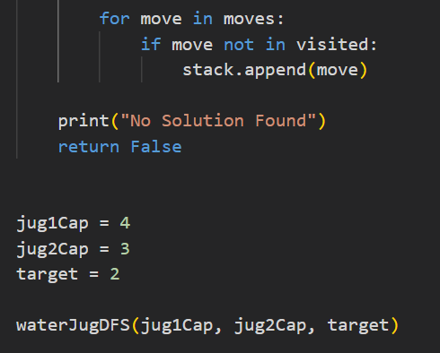

The program starts with jug capacities (4,3) and tries to measure 2 units of water.

**Example Output**

Solution Found:  
(0, 0)  
(4, 0)  
(1, 3)  
(1, 0)  
(0, 1)  
(4, 1)  
(2, 3)  
(2, 0)